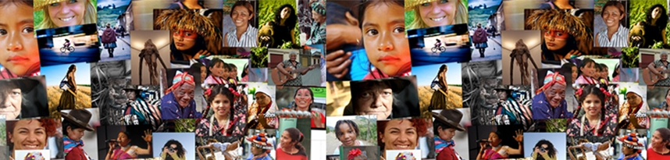


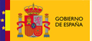
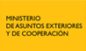


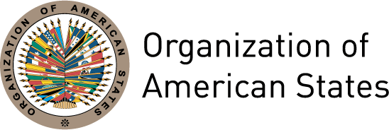

Hemispheric Forum

“Women’s leadership for a citizens’ democracy”

April 4th to 6th 2011

Washington, DC

In support of the commitments adopted by the member states of the Organization of American States (OAS) and the United Nations (UN) through the International Covenant on Civil and Political Rights, the Convention on the Elimination of all Forms of Discrimination against Women (CEDAW), the Inter-American Democratic Charter and other agreements, the Inter-American Commission of Women, UN Women and the Ibero-American General Secretariat (SEGIB) are organizing the First Hemispheric Forum on Women’s Leadership for a Citizens’ Democracy.

The last five years have seen a plethora of national and hemispheric-level dialogue on the main challenges to the construction of a citizens’ democracy, as well as the meaning of democratic systems and their institutions. However, these dialogues have not substantively considered women’s political rights or the issue of parity in political representation.

In the interest of placing women’s voices, visions and rights at the centre of political reform, democratization and State modernization processes, CIM, UN Women and SEGIB will initiate a continuous dialogue with the aim of enhancing understanding of the implications of a citizens’ democracy for the rights and interests of women, in all their diversity.

The dialogue will be launched during the hemispheric forum, with the following objectives:

- Bring women’s visions, experiences and aspirations to the construction of citizens’ democracy with full equality for men and women.
- Strengthen understanding of the current challenges that democratic systems in order to guarantee the exercise of women’s substantive political citizenship.

Monday, April 4th 2011
Hall of the Americas (17th St. and Constitution Ave.)

9:00- 9:45 Registration
Participants will need to be seated by 9:45am for the entry of the Prime Minister of Trinidad and Tobago

10:00-11:00 Inauguration
- Rocío García Gaytán, President of CIM
- Enrique Iglesias, Secretary General, Ibero-American General Secretariat (SEGIB) (video message)
- Gladys Acosta, Chief of the Latin America and Caribbean Section, UN Women
- Muni Figueres, Ambassador of Costa Rica to the United States on behalf of the President of Costa Rica, Laura Chinchilla
- José Miguel Insulza, Secretary General of the Organization of American States (OAS)

11:00-12:00 Keynote Address
The challenges of the democratic system to women’s equality in Latin America and the Caribbean
Moderator: José Miguel Insulza, Secretary General of the OAS

The Honourable Kamla Persad-Bissessar, Prime Minister of Trinidad & Tobago,

12:00-1:00 Question and answer session

1:00-2:30 Lunch

2:30-4:00 Panel
The agenda for a citizens’ democracy and governability in the Americas
Moderator: Gillian M.S. Bristol, President of the Permanent Council of the OAS

- José Antonio Ocampo, School of International and Public Affairs, Columbia University
- Susana Villarán, Mayor of Lima, Peru
- Kenny D. Anthony, Former Prime Minister and Leader of the Opposition of Saint Lucia
- Line Barreiro, Expert of the UN Committee for the Elimination of all Forms of Discrimination against Women (CEDAW)

4:00-4:15 Official event photo

4:15-4:30 Break

4:30-5:30 Question and answer session

5:30-6:00 Results of the preparatory virtual forum
    - Sara Lovera, Moderator of the virtual forum

6:00-8:00 Welcome cocktail offered by the Delegation of Mexico (Patio Azteca)
April 5th 2011
Rubén Darío Room (1889 F Street, N.W)

9:30-11:15 Panel
The exercise of women’s political rights in the Americas
Moderator: Virginia Vargas, International expert on women’s rights, democracy and participation

- State of the art: The exercise of women’s political rights in the Americas
Luz Patricia Mejía, Special Rapporteur for the Rights of Women, IACHR/OAS
- Challenges to monitoring the exercise of women’s political rights
Elizabeth Abi-Mershed, Deputy Executive Secretary, Inter-American Commission on Human Rights (IACHR)
- Hemispheric monitoring of the exercise of women’s political rights
Rosemary Madden, Inter-American Institute of Human Rights (IIDH)
  - The role of CEDAW in the construction of women’s citizenship
Silvia Pimentel, Expert, Committee for the Elimination of all Forms of Discrimination against Women (CEDAW)

11:15-11:30 Break

11:30-12:30 Question and answer session

12:30-3:00 Lunch

3:00-4:45 Panel
Contemporary perspectives on democracy, women’s citizenship and the State
Moderator: Daniela Payssé, President of the Special Commission on Gender and Equity, Uruguay

- Perspectives on democracy and women’s political citizenship
  - Virginia Vargas, International expert on women’s rights, democracy and participation
  - Pablo Zúñiga, OAS Specialist
  - Line Barreiro, Expert of the UN Committee for the Elimination of all Forms of Discrimination against Women (CEDAW)

4:45-5:00 Break

5:00-6:00 Question and answer session

Wednesday April 6th 2011
Rubén Darío Room (1889 F Street, N.W)

10:00-11:30 Concurrent panels

Panel I (Rubén Darío Room, 8th floor)
Parliaments and the women’s rights agenda: State of the art and current challenges
Moderator: Minou Tavares, Vice-President of the of the Parliamentary Confederation of
the Americas (COPA), Dominican Republic, Dominican Republic

- Sheila Copps, former Deputy Prime Minister of Canada
- Otilia Lux de Cotí, Deputy, Congress of Guatemala
- Daniela Payssé, President of the Special Commission for Gender and Equity, Uruguay
- Xanthis Suárez, Deputy of the Central American Parliament (PARLACEN), Nicaragua
- Solanda Goyes, Specialist Agora Democrática/International IDEA

Panel II (Padilla Vidal Room, TL level)
Electoral system reform and women’s political rights
Moderator: Pablo Gutiérrez, Director of the Department of Cooperation in Electoral Observation (DECO), OAS

- Ana María Yañez, Advisor on women’s political rights, Manuela Ramos Movement
- Cynthia Barrow-Giles, Senior lecturer in politics, University of the West Indies
- Marcela Ríos, Researcher on women and electoral systems

11:30-12:15 Women’s full citizenship for democracy and development in the Americas
Michelle Bachelet, Under-Secretary-General and Executive Director of UN Women

12:15-1:00 Question and answer session

1:00-2:30 Lunch

2:30-4:00 Panel (Rubén Darío Room, 8th floor)
Political parties: State of the art and stance on women’s rights
Moderator: Begoña Lasagabaster, UN Women

- Mia A. Mottley, former Deputy Prime Minister of Barbados
- Susana Villarán, Mayor of Lima
- Ada Rosa Del Valle Iturrez De Cappellini, President of the Commission on Population and Development, Congress of Argentina
- Vivian Roza, Coordinator, Program for the Support of Women's Leadership and Representation (PROLEAD), Inter-American Development Bank (IADB)

4:00-4:15 Break

4:15-5:00 Question and answer session

5:00-6:00 Recap
Challenges to advancing women’s substantive political citizenship in the Americas
Moderators: President and Vice-presidents of the CIM

- Presentation by the Rapporteurs
- Plenary debate

6:00-6:30 Closing session
  - Javier Sancho, Permanent Observer of Spain to the OAS
  - Rocío García Gaytán, President of the CIM

For those not able to attend in person, the entire event will be Webcast live

